2019-2020 Pa Hockey Champions –

– Cathedral Prep ~ 20199 Governor’s Cup of New York

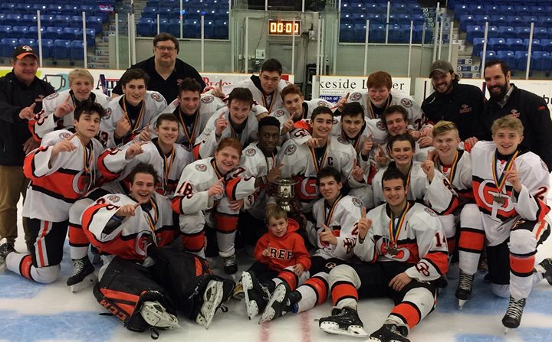

– Latrobe Wildcats ~ 2019 Pa Hockey Scholastic Showcase - Director’s Cup of Pennsylvania
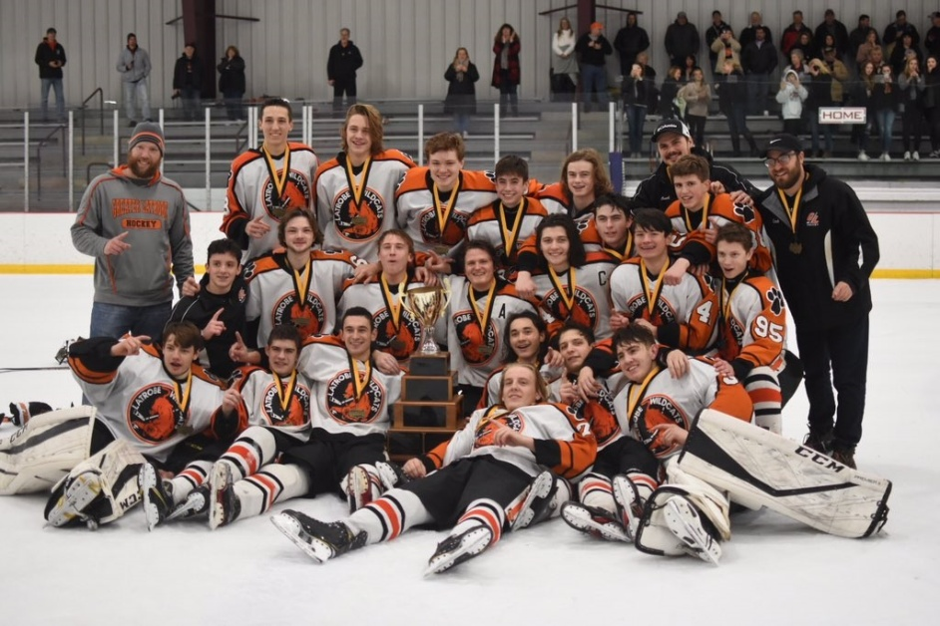

– New Trier Green & Glenbrook North ~ 2020 Hoosier Cup - Governor’s Cup of Indiana

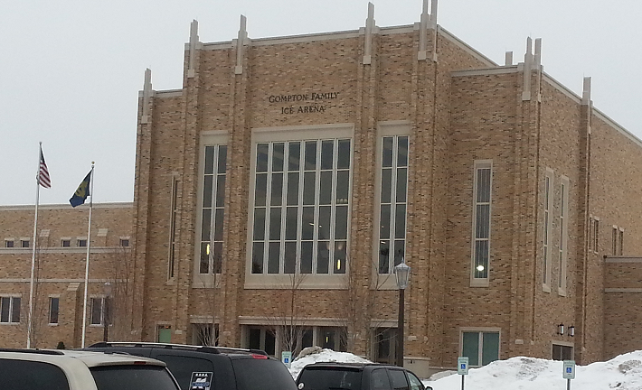

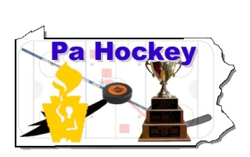
Pa Hockey
Pennsylvania’s # 1 Interscholastic Hockey Website
www.pahockey.net
Governor’s Cup Events

15th Annual National Invitational Scholastic Showcase

December 3rd - 5th, 2021~ Jamestown Savings Bank – Jamestown, NY

25th Pa Hockey Scholastic Showcase

December 26-29, 2021 ~ Alpha Ice Complex – Pittsburgh, Pa.

6th Annual Hoosier Cup Scholastic Showcase

February 4-6, 2022 ~ Compton Family Ice Arena – South Bend, Indiana

“THE MOST COMPETITIVE FIELDS OF ANY HIGH SCHOOL HOCKEY TOURNAMENT in THE USA”

The Pa Hockey Foundation is sponsoring the National Invitational Scholastic Showcase events in New York Pennsylvania and Indiana. These Events features the top High School Hockey programs in the country for the three-day events during the 2021-2022 season. Your school is invited to apply for participation in a 12-16 team showcase of the top Varsity high school teams from across the United States to compete for the Governor’s Cup of New York, Pennsylvania and Indiana.

The Goal of these Invitational Events is to feature National, State Champions, Finalists, Semi-Finalists and Outstanding High School Hockey Programs and we will attempt to limit field 4 from any particular area [State or Region] to ensure that each school participating will face three uncommon opponents in the preliminary round of competition. The tournament will be played on 2 rinks in prime time for this round robin event.

Invitations will be to High School Hockey Programs from across the United States in the Spring of 2021. If a school is interested in participating in this event, it should mail or e-mail a fully executed ‘Letter of Interest’ and the Deposit of $ 500 to the Pa Hockey Foundation NO LATER than May 31st 2021.

Should you have any questions, please contact Jeff Mauro at 412-848-3750 [Cell Phone] E-Mail at JEFFMAURO@AOL.COM

PLEASE SEE THE CHECKLIST ON PAGE 3 + 4 & 5 of APPLICATION TO SECURE SPOTS INN OUR OTHER EVENTS DURING THE 2021-2022 SEASON IN JAMESTOWN, PITTSBURGH AND SOUTH BEND

Pa Hockey
Pennsylvania’s # 1 Interscholastic Hockey Website
www.pahockey.net

PA Hockey EVENT - LETTER OF INTEREST
Important Dates:
- Early Invitations – If your school is a returning NISS Participant, please submit your Advanced Registration by May 31, 2021 to hold your spot
- Advanced Registration Fee = $ 500.00 DUE by May 31, 2021
- Total Entrance Fee = Please See Below for the Tournament of Interest and Mail the Balance Due as your commitment to the Tournament by October 31, 2021
- USA Hockey and League Rosters DUE by October 31, 2021
YOUR SCHOOL PLAYS UNDER THE FOLLOWING ASSOCIATION:
USA HOCKEY ________ National High School Federation________ Prep __________

Our Club is interested in participating in the 2021-2022 National Invitational Scholastic Showcase Tournaments in New York, Pennsylvania or Indiana
Step 1 – Participant Acknowledgement and Letter of Interest
Head Coach _____________________________________ Date ___________________
Club Representative ______________________________ Date ___________________

Step 2 – Participant Application and Deposit
Step 3 – Final Payment and Rosters

Entrants should mail (Pa Hockey P.O. Box 10598 Pgh, Pa. 15235) a check for the FINAL PAYMENT and ALL Rosters to the “Pa Hockey Foundation”
PLEASE RETURN THIS FORM WITH A CHECK MADE PAYABLE TO:
Pa Hockey Foundation – P.O. Box 10598, Pittsburgh, Pa 15235

PA HOCKEY FOUNDATION EVENTS

NISS – Jamestown VARSITY 1625

NISS – Pittsburgh VARSITY 1525 JUNIOR VARSITY 1425

NISS – South Bend VARSITY 1925

PLEASE READ THE HOOSIER CUP CRITERIA ON PAGE 5

PLEASE CHECK BOX AND CIRCLE CHOICES

Deposits, Payment Due Dates and Cancellation Policies
Teams may register by completing the registration form and sending with full payment or a $500 non-refundable deposit. Payments may be made by check.
Teams canceling their tournament entry within thirty days of the tournament start date are not entitled to any type of refund. If we are able to fill your team's spot with a team that is paying an entry fee to play in the tournament, we will apply a credit to entry in a future tournament. No refunds, by cash or check, will be made.

Pa Hockey
Pennsylvania’s # 1 Interscholastic Hockey Website
www.pahockey.net
Governor’s Cup Events

6th Annual Hoosier Cup Scholastic Showcase

February 4-6, 2022 ~ Compton Family Ice Arena – South Bend, Indiana

2022 Hoosier Cup – Selection Process
For the 2022 Hoosier Cup, Schools will be chosen using the Automatic Bid Selection Process. If your school qualifies under the criteria below and your application is received prior to May 31st 2021 , your school will be given an automatic bid to the 2022 Hoosier Cup [Please note if more Schools apply than Spots Available Higher Seeding State Champions and Finalists will be given first preferences)
Hoosier Cup Qualification Criteria 16 Schools

The 2022 Hoosier Cup Field will use the 2021 Qualification Process to choose the field. All 16 Schools chosen will have the opportunity to participate by simply returning this application with the deposit of $ 500.00 by May 15th 2021 to secure their spot in the field. These schools include:

6th Annual Hoosier Cup Scholastic Showcase – February 4-6 2022 in South Bend, Indiana
Carmel Gold - Indiana - FINAL 4 5A Participant
Culver Academy - Indiana - FINAL 4 5A Champions
DeMatha Catholic - Maryland - 2020 NISS Final 4 HCISS
Edina - Minnesota - Minnesota - State FINAL 4
Erie Cathedral Prep - Pennsylvania - 2019 NISS Champions
Glenbrook North - Illinois - 2020 Final 4 Varsity Red
Glenbrook South - Illinois - 2020 Final 4 Varsity Red
Hamilton SE - Indiana 2020 4 A Champions
Lake Central – Indiana – At Large Selection
Meadville – Pennsylvania – At Large Selection
Medina - Ohio - 2020 Final 4 State
North Allegheny - Pennsylvania - 2020 Final 4 Penguins Cup
Peters Township - Pennsylvania - 2020 Final 4 Penguins Cup
St Joseph's Prep - Pennsylvania - 2020 Final 4 Flyers Cup
Wayzata - Minnesota - State FINAL 4
York - Illinois - 2020 Final 8 Varsity Red

After May 15th, 2021, the field will be opened up to fill the remaining spots opened by this process.

